COURSE NAME: Principals of Programming
LECTURE TOPIC / MODULE: Introduction to Programming Concepts / Module 6
DATE(S): 08.18.25 – 08.24.25
INSTRUCTOR: Steven Evans
KEY CONCEPTS:
- Describe Python list methods.
- Analyze looping over Python lists, list comprehensions, and dictionaries.
- Develop Python programs that create and manipulate lists.
- Design Python programs that create and manipulate dictionaries.
DEFINITIONS:
- A list is a container, which is an object that groups related objects together.
  - A list is also a sequence; thus, the contained objects maintain a left-to-right positional ordering.
  - Each element in a list can be a different type such as strings, integers, floats, or even other lists.
- The list() function accepts a single iterable object argument, such as a string, list, or tuple, and returns a new list object.
  - Ex: list('abc') creates a new list with the elements ['a', 'b', 'c'].
- An index is a zero-based integer matching to a specific position in the list's sequence of elements. A programmer can reference a specific element in a list by providing an index.
  - my_list[4] uses an integer to access the element at index 4 (the 5th element) of my_list
  - An index can also be an expression, as long as that expression evaluates into an integer. Replacing the index with an integer variable, such as in my_list[i], allows the programmer to quickly and easily lookup the (i+1)th element in a list.
- A list method can perform a useful operation on a list such as adding or removing elements, sorting, reversing, etc.
- sort(), performs an in-place rearranging of the list elements, sorting the elements from lowest to highest.
- The sorted() built-in function provides the same sorting functionality as the list.sort() method, however, sorted() creates and returns a new list instead of modifying an existing list.
- The key specifies a function to be applied to each element prior to being compared. Examples of key functions are the string methods str.lower, str.upper, or str.capitalize.
- The reverse argument can be set to a Boolean value, either True or False. Setting reverse=True flips the sorting from lower-to-highest to highest-to-lowest.
- for loop, used specifically for iteration purposes.
- Accessing an index that is out of range causes the program to automatically abort execution and generate an IndexError.
- The built-in enumerate() function iterates over a list and provides an iteration counter. The program above uses the enumerate() function, which results in the variables pos and token being assigned the current loop iteration element's index and value, respectively.
- Embedding of a list inside another list is known as list nesting.
- A programmer can use slice notation to read multiple elements from a list, creating a new list that contains only the desired elements.
- An optional component of slice notation is the stride, which indicates how many elements are skipped between extracted items in the source list.
  - Ex: The expression my_list[0:5:2] has a stride of 2, thus skipping every other element, and resulting in a slice that contains the elements in positions 0, 2, and 4. The default stride value is 1 (the expressions my_list[0:5:1] and my_list[0:5] being equivalent).
- List comprehension, iterates over a list, modifies each element, and returns a new list consisting of the modified elements.
- Command-line arguments are values entered by a user when running a program from a command line.
- sys.argv, is stored in the standard library sys module. sys.argv consists of one string element for each argument typed on the command line.
- Usage message, provides the user with an example of the correct command-line argument format.
- The dict type implements a dictionary in Python.
  - There are several approaches to create a dict:
    - The first approach wraps braces { } around key-value pairs of literals and/or variables: {'Jose': 'A+', 'Gino': 'C-'} creates a dictionary with two keys 'Jose' and 'Gino' that are associated with the grades 'A+' and 'C-', respectively.
    - The second approach uses dictionary comprehension, which evaluates a loop to create a new dictionary, similar to how list comprehension creates a new list. Dictionary comprehension is out of scope for this material.
    - Other approaches use the dict() built-in function, using either keyword arguments to specify the key-value pairs or by specifying a list of tuple-pairs. The following creates equivalent dictionaries:
dict(Bobby='805-555-2232', Johnny='951-555-0055')
dict([('Bobby', '805-555-2232'), ('Johnny', '951-555-0055')])
- A dictionary method is a function provided by the dictionary type (dict) that operates on a specific dictionary object.
  - Dictionary methods can perform some useful operations, such as adding or removing elements, obtaining all the keys or values in the dictionary, merging dictionaries, etc.
- A hash is a transformation of the key into a unique value that allows the interpreter to perform very fast lookup.
- A view object provides read-only access to dictionary keys and values. A program can iterate over a view object to access one key-value pair, one key, or one value at a time, depending on the method used. A view object reflects any updates made to a dictionary, even if the dictionary is altered after the view object is created.
  - dict.items() – returns a view object that yields (key, value) tuples.
  - dict.keys() – returns a view object that yields dictionary keys.
  - dict.values() – returns a view object that yields dictionary values.

FORMULAS / NOTES:
- A list's index must be an integer type. The index cannot be a floating-point type, even if the value is 0.0, 1.0, etc.
- Unlike the string sequence type, a list is mutable and is thus able to grow and shrink without the program having to replace the entire list with an updated copy.
  - Such growing and shrinking capability is called in-place modification.
- In-place modification affects any variable that references the list, and thus can have unintended side-effects.
- The correct approach would have been to create a copy of the list instead. One simple method to create a copy is to use slice notation with no start or end indices, as in your_teams = my_teams[:].
- Good practice is to use list methods to add and delete list elements, rather than alternative add/delete approaches.
- The list.sort() and list.reverse() methods rearrange a list element's ordering, performing in-place modification of the list.
- The list.index() and list.count() return information about the list and do not modify the list.
- Lower-case letters have a larger encoded value than upper-case letters.
- A programmer might want to sort a two-dimensional list by the max of the rows, which can be accomplished by assigning key to the built-in function max, as in: sorted(x, key=max).
- A programmer can access all of the elements of nested lists by using nested for loops.
- A list comprehension has three components:
  - An expression component to evaluate for each element in the iterable object.
  - A loop variable component to bind to the current iteration element.
  - An iterable object component to iterate over (list, string, tuple, enumerate, etc).
A list comprehension is always surrounded by brackets, which is a helpful reminder that the comprehension builds and returns a new list object.
- List comprehension is not an exact replacement of for loops, because list comprehensions create a new list object, whereas the typical for loop is able to modify an existing list.
- A list comprehension can be extended with an optional conditional clause that filters out elements from the resulting list.
  - new_list = [expression for name in iterable if condition]
  - Using the above syntax will only add an element to the resulting list if the condition evaluates to True.
- When a program uses command-line arguments, a good practice is to always check the length of argv at the beginning of the program to ensure that the user entered the correct number of arguments.
- A good practice is to always output a usage message when the user enters incorrect command-line arguments.
- Note that all command-line arguments in argv are strings. If an argument represents a different type like a number, then the argument needs to be converted using one of the built-in functions such as int() or float().
- Dictionaries contain references to objects as key-value pairs – each key in the dictionary is associated with a value, much like each word in an English language dictionary is associated with a definition.
EXAMPLE(S) / ILLUSTRATION(S):
- Modify the program to print the correct ordinal number ("1st", "2nd", "3rd", "4th", "5th") instead of "1th", "2th", "3th", "4th", "5th".
2. For the oldest person, remove the ordinal number (1st) from the print statement to say, "The oldest person lived 122 years".
oldest_people = [122, 119, 117, 117, 116]
def get_ordinal(n):
if 10 <= n % 100 <= 20:
suffix = 'th'
else:
suffix = {1: 'st', 2: 'nd', 3: 'rd'}.get(n % 10, 'th')
return f"{n}{suffix}"
nth_person = int(input('Enter N (1-5): '))
if 1 <= nth_person <= 5:
age = oldest_people[nth_person - 1]
if nth_person == 1:
print(f"The oldest person lived {age} years")
else:
print(f"The {get_ordinal(nth_person)} oldest person lived {age} years")
else:
print("Please enter a number between 1 and 5.")

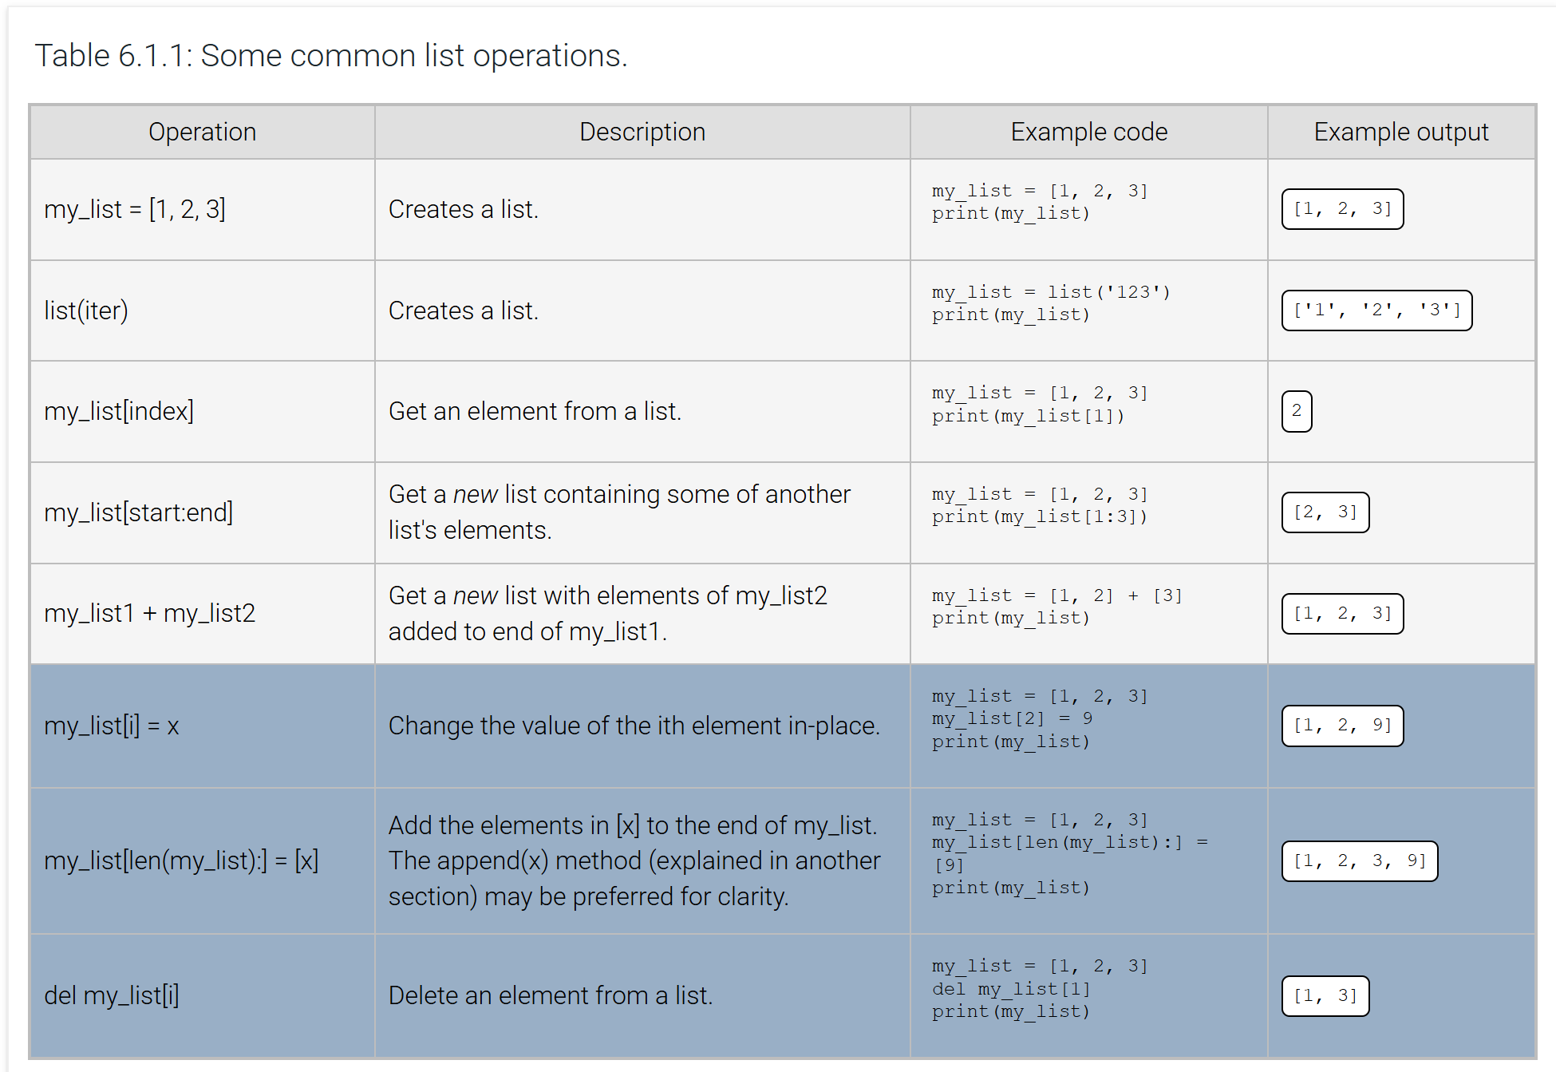
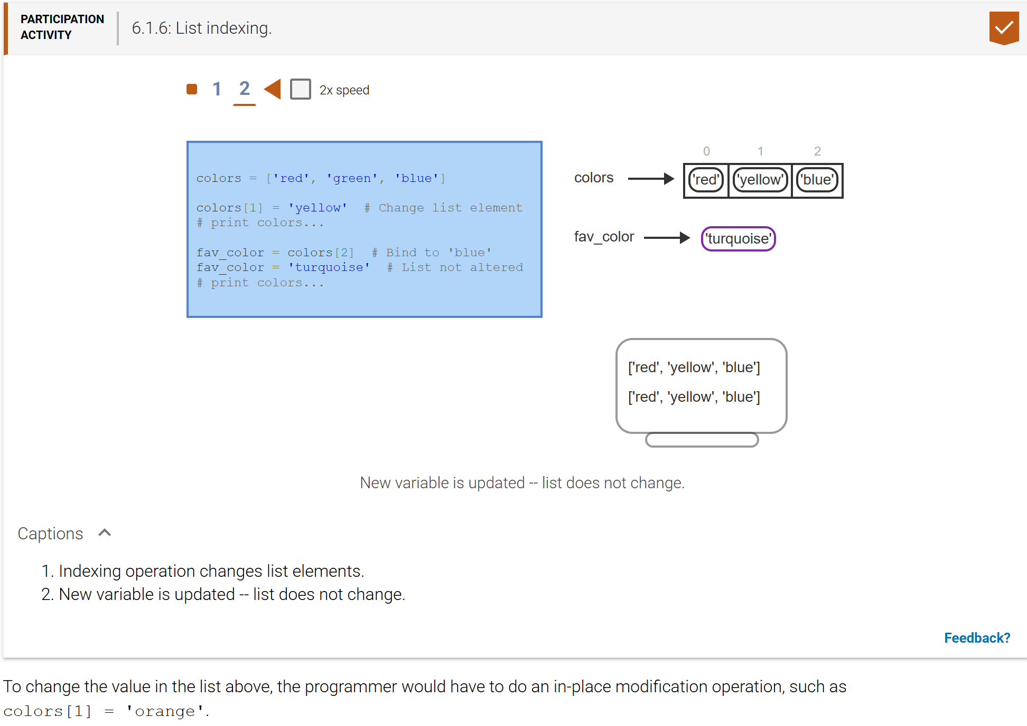
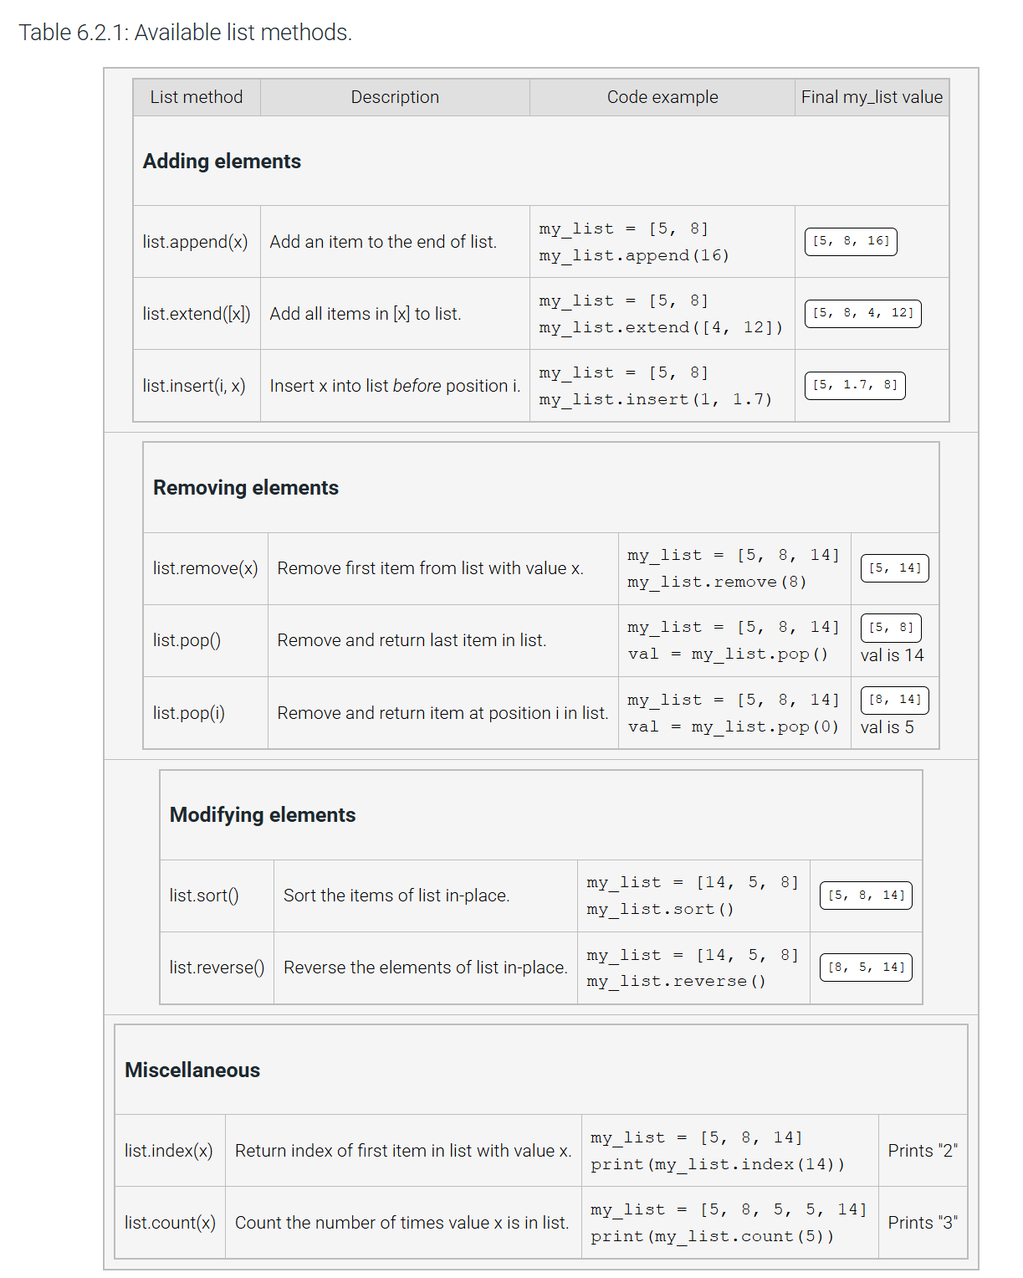
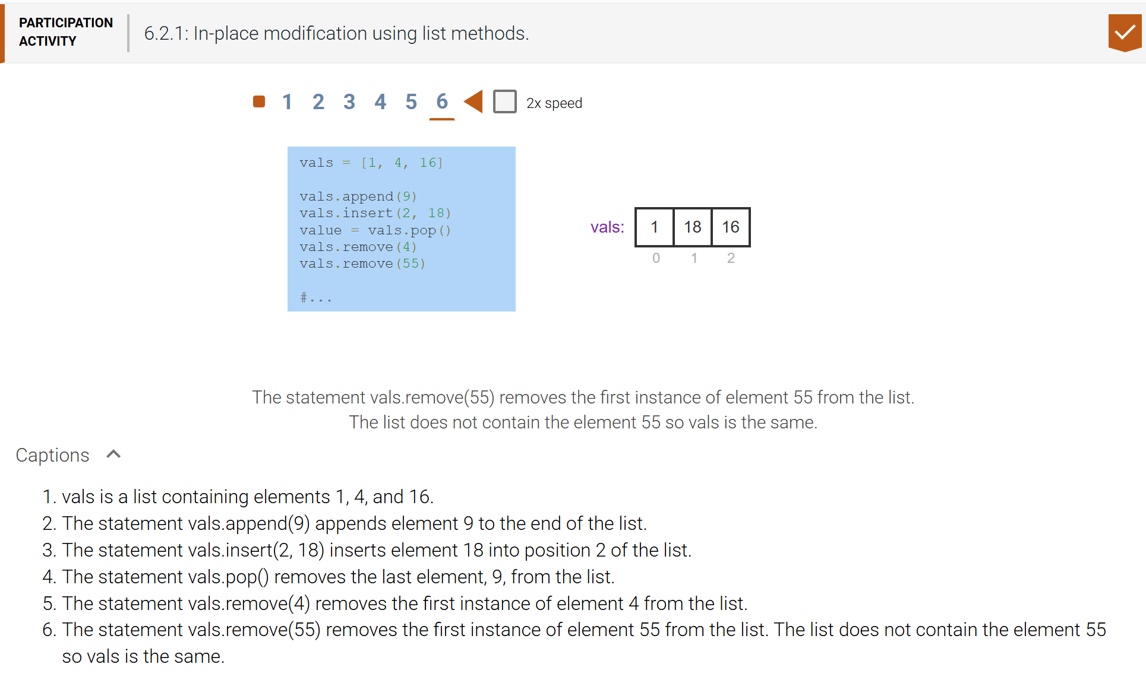
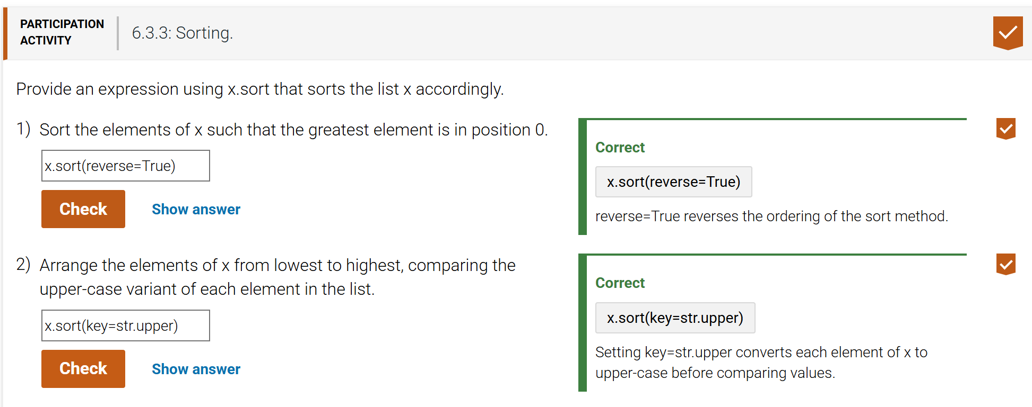
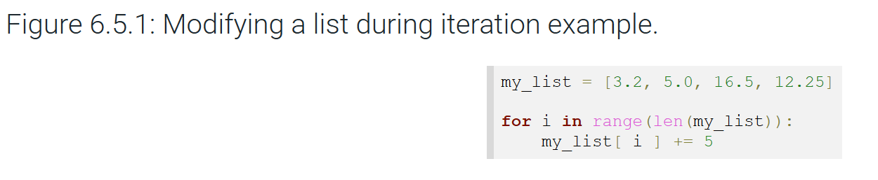

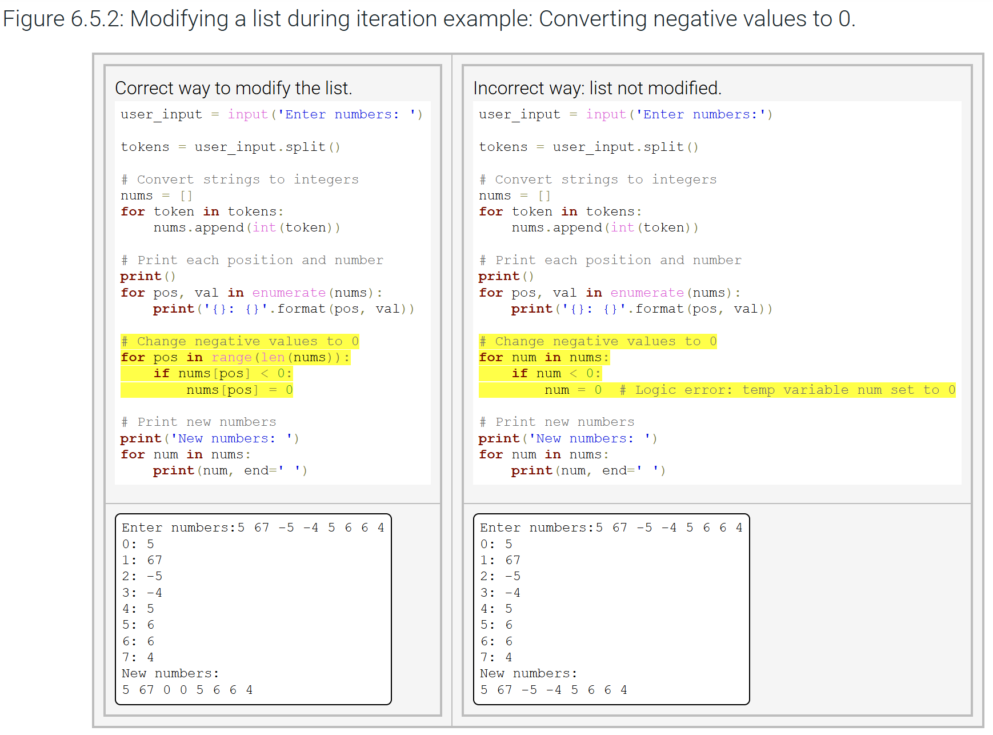
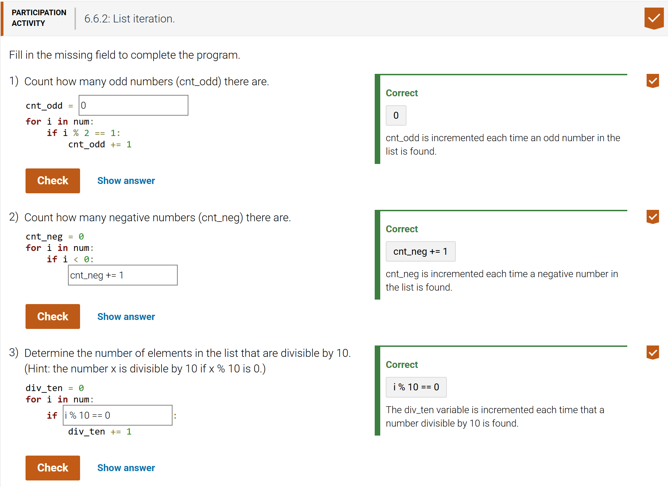
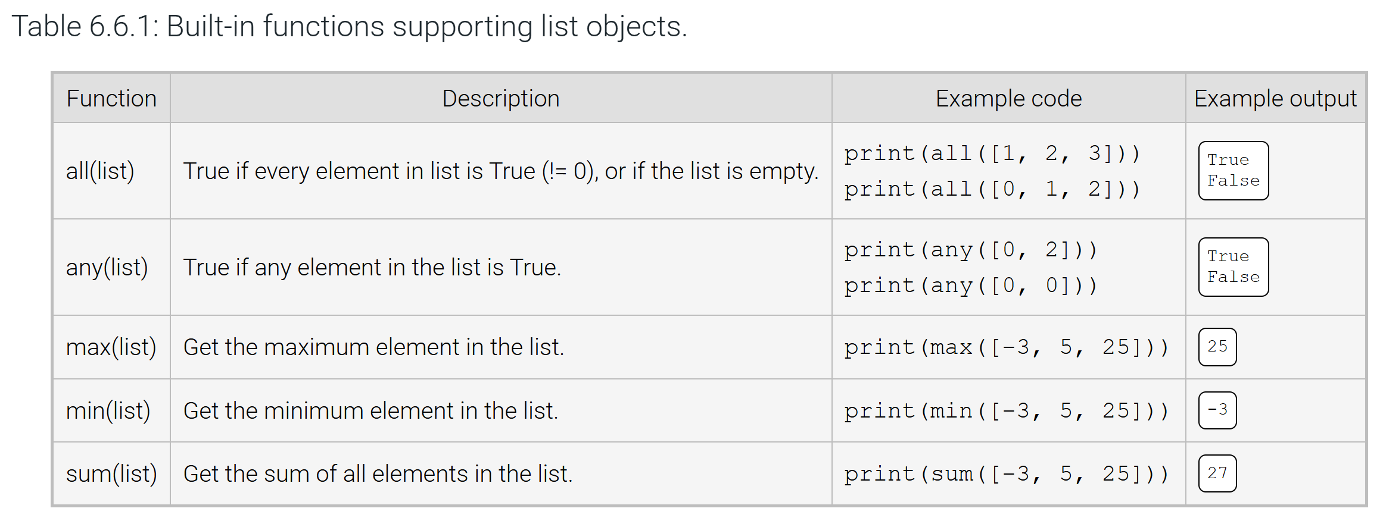
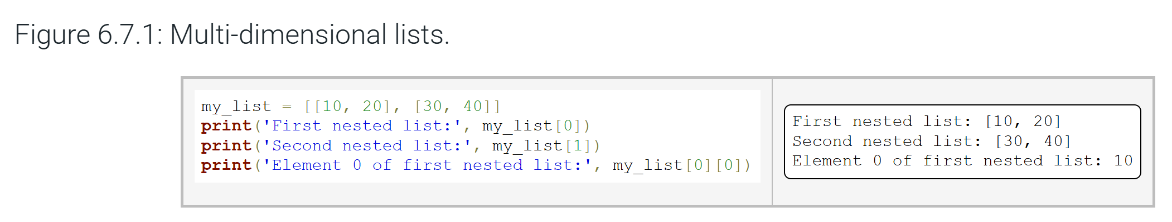
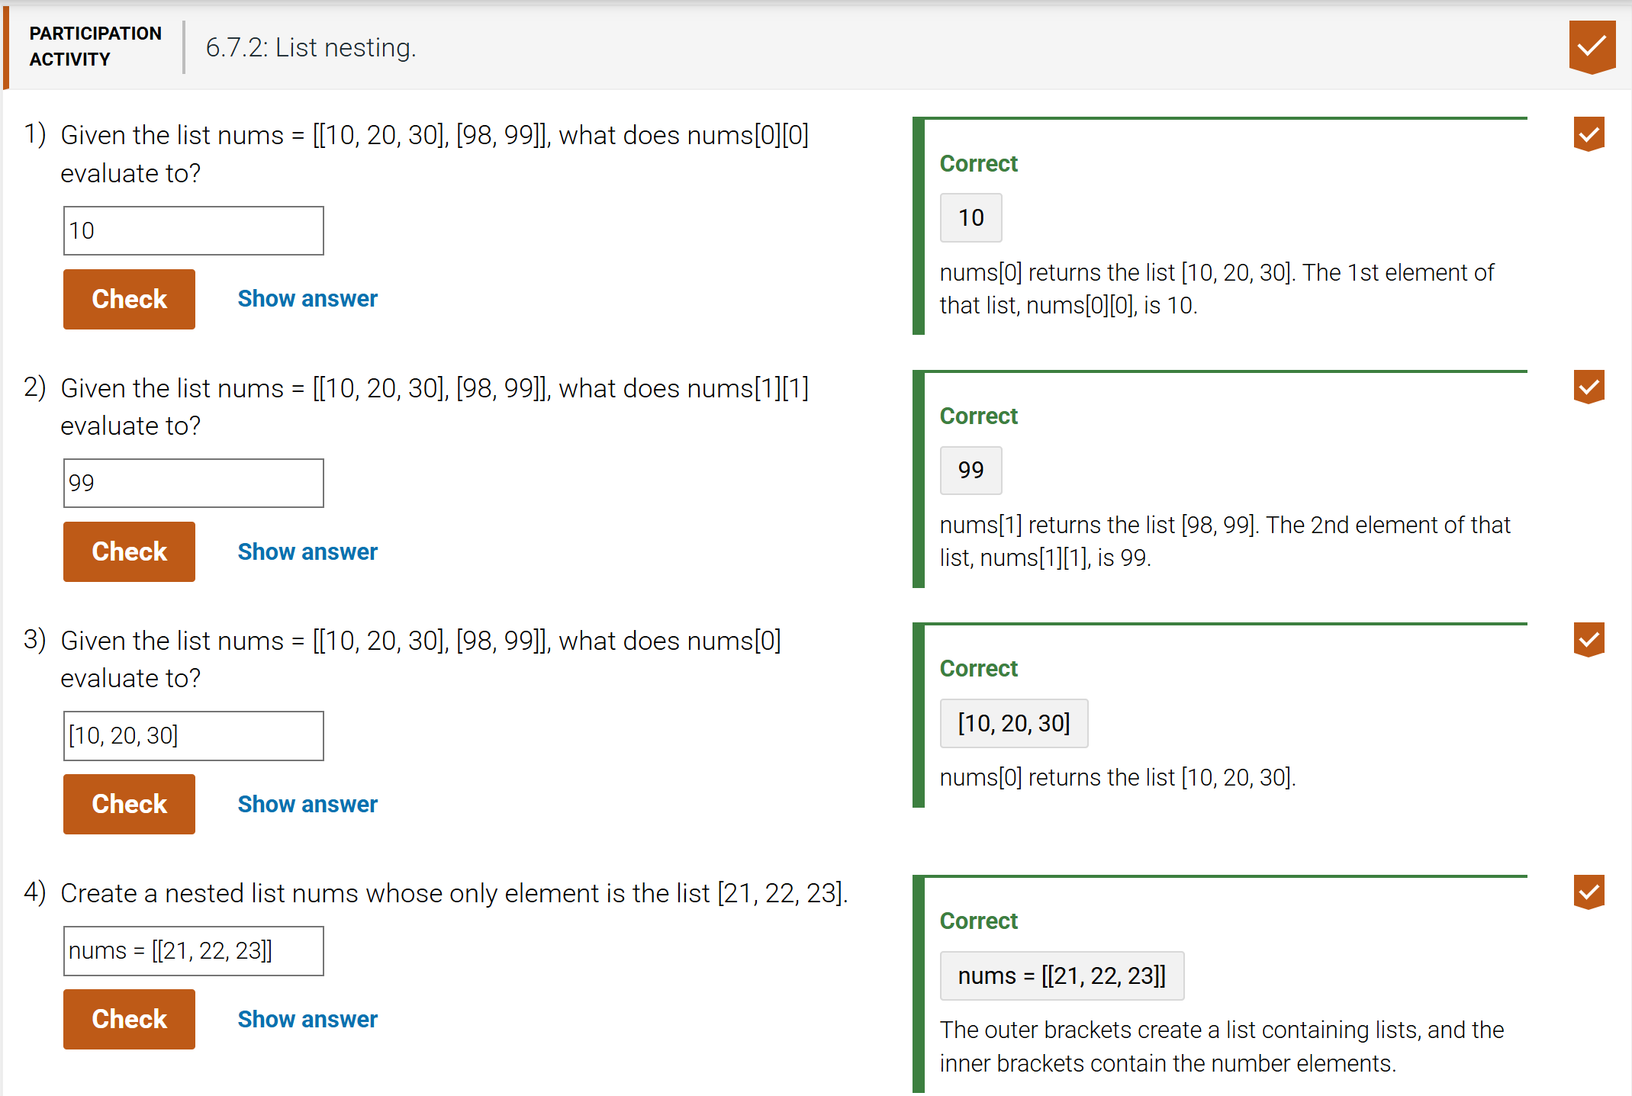
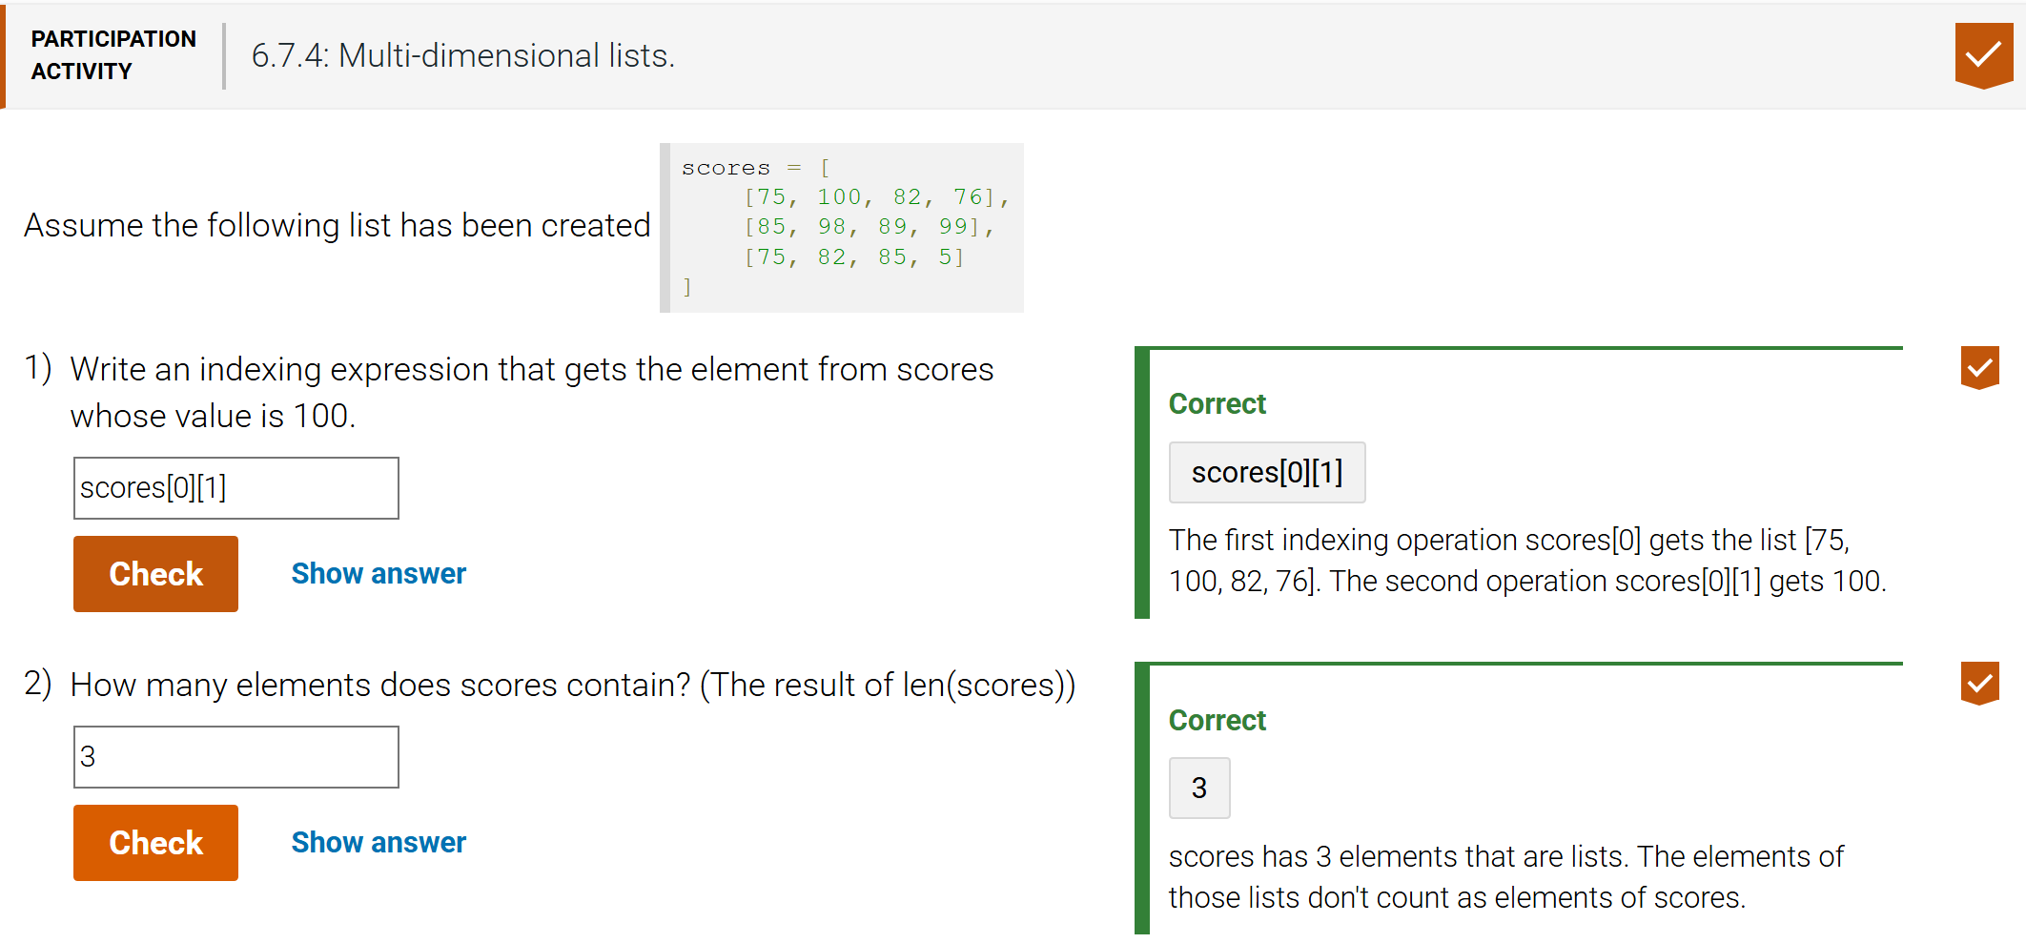
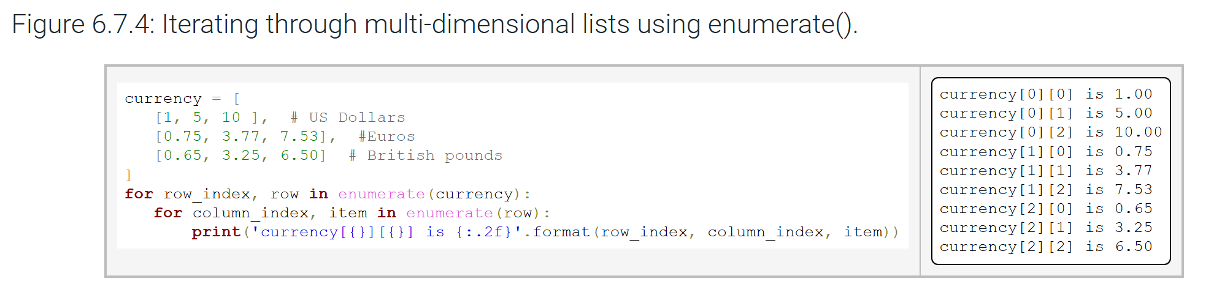
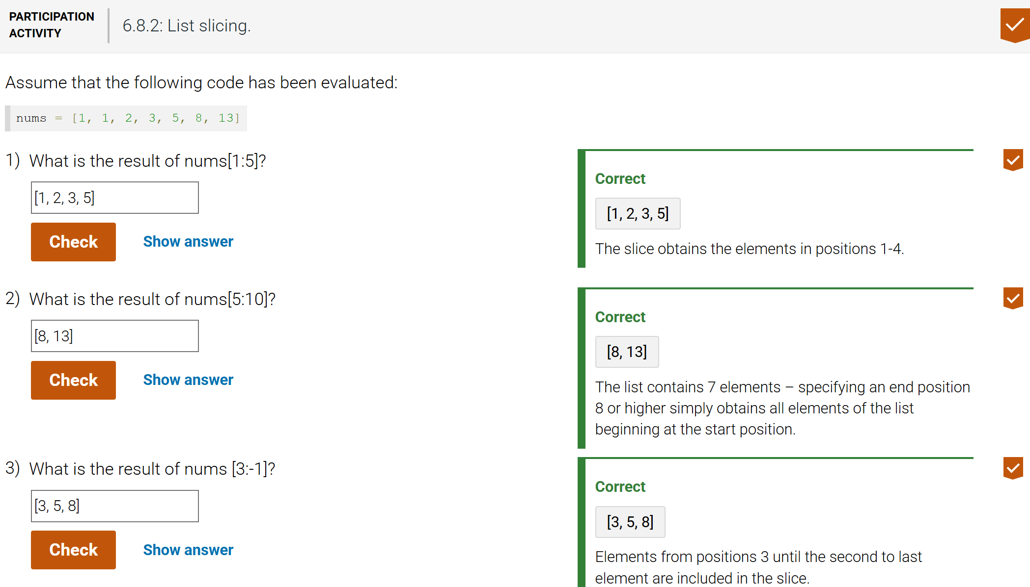
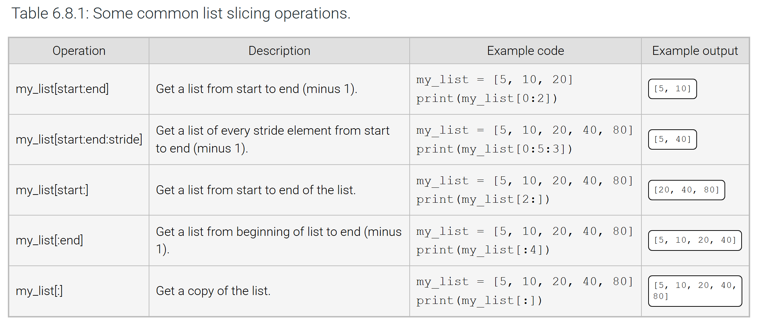
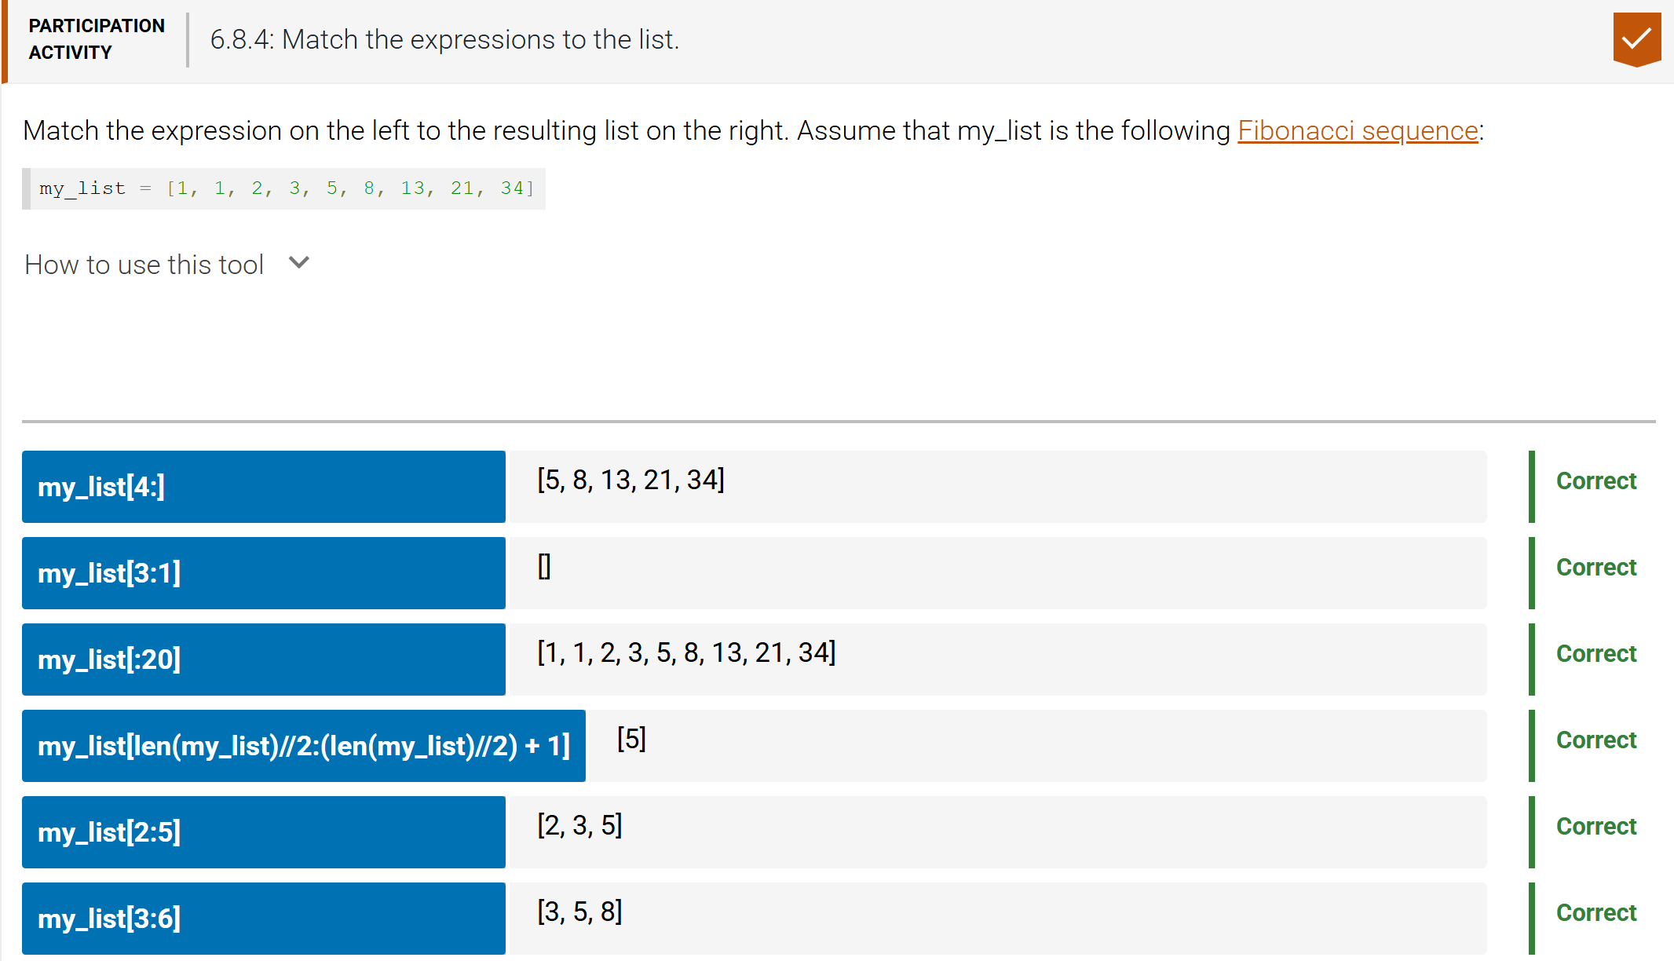
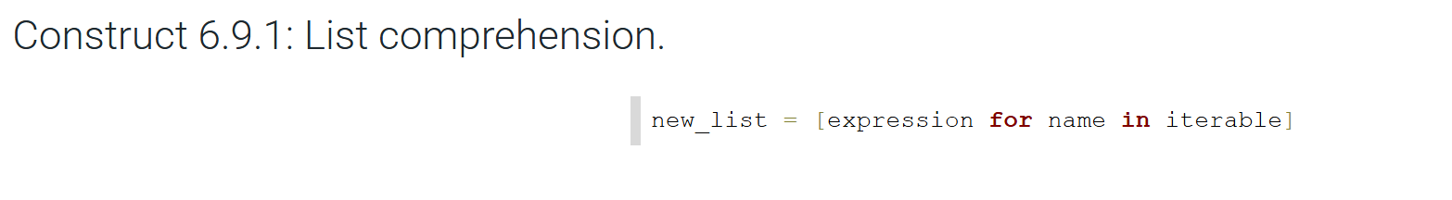
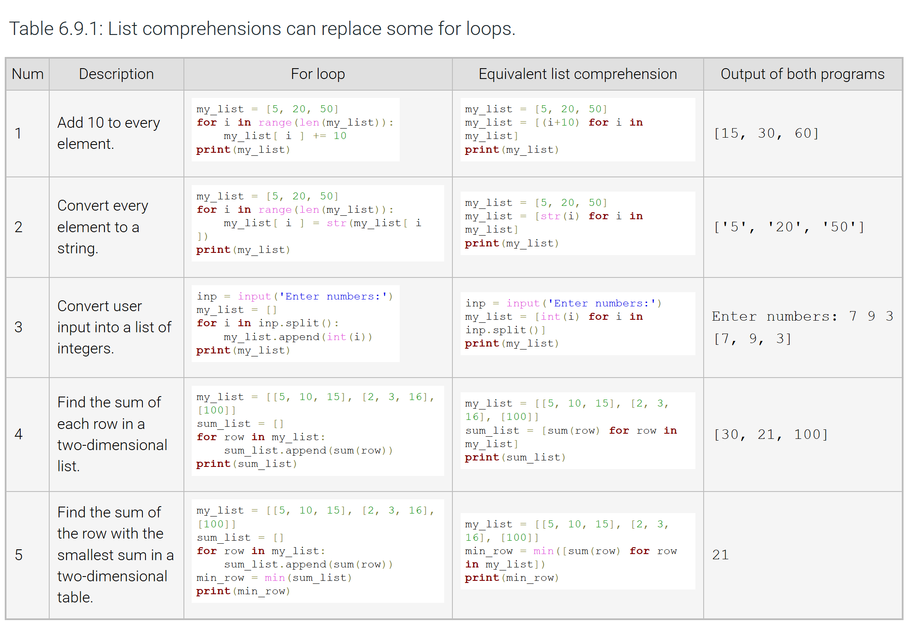
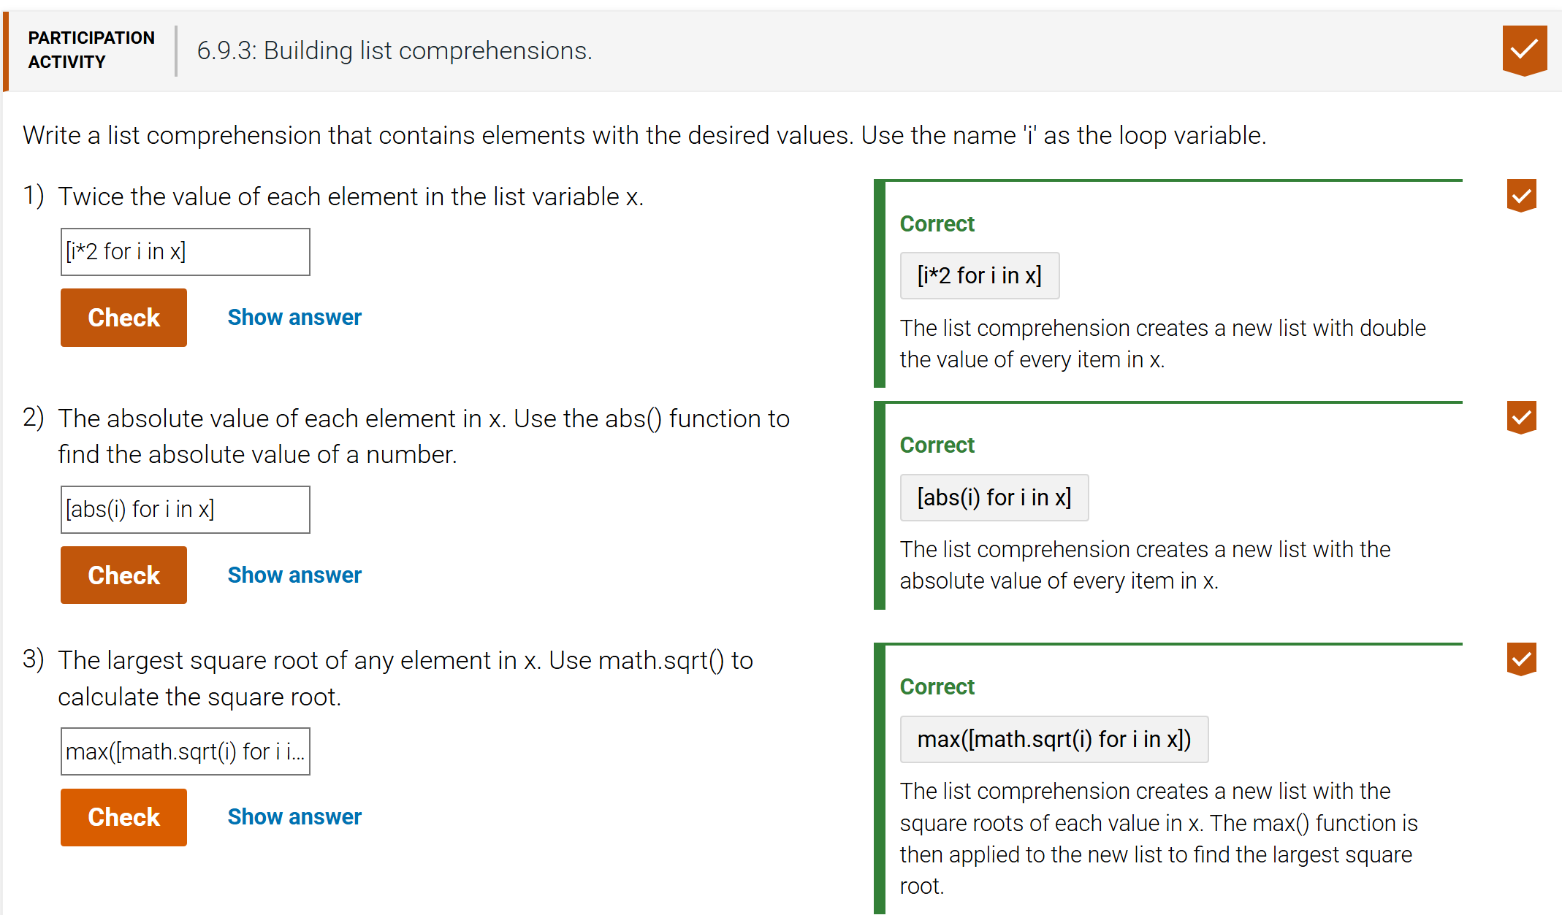
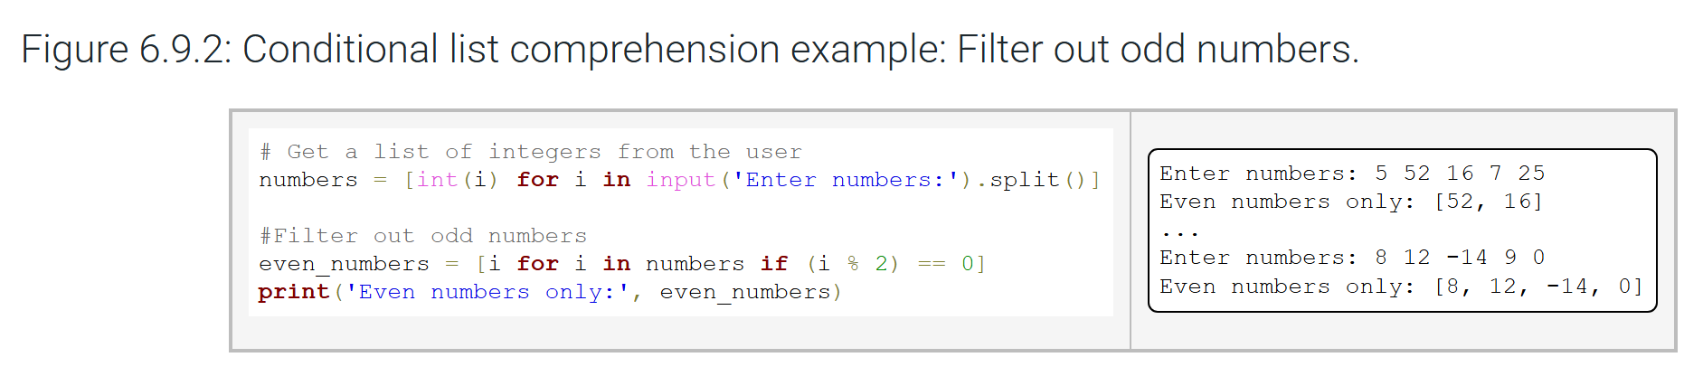
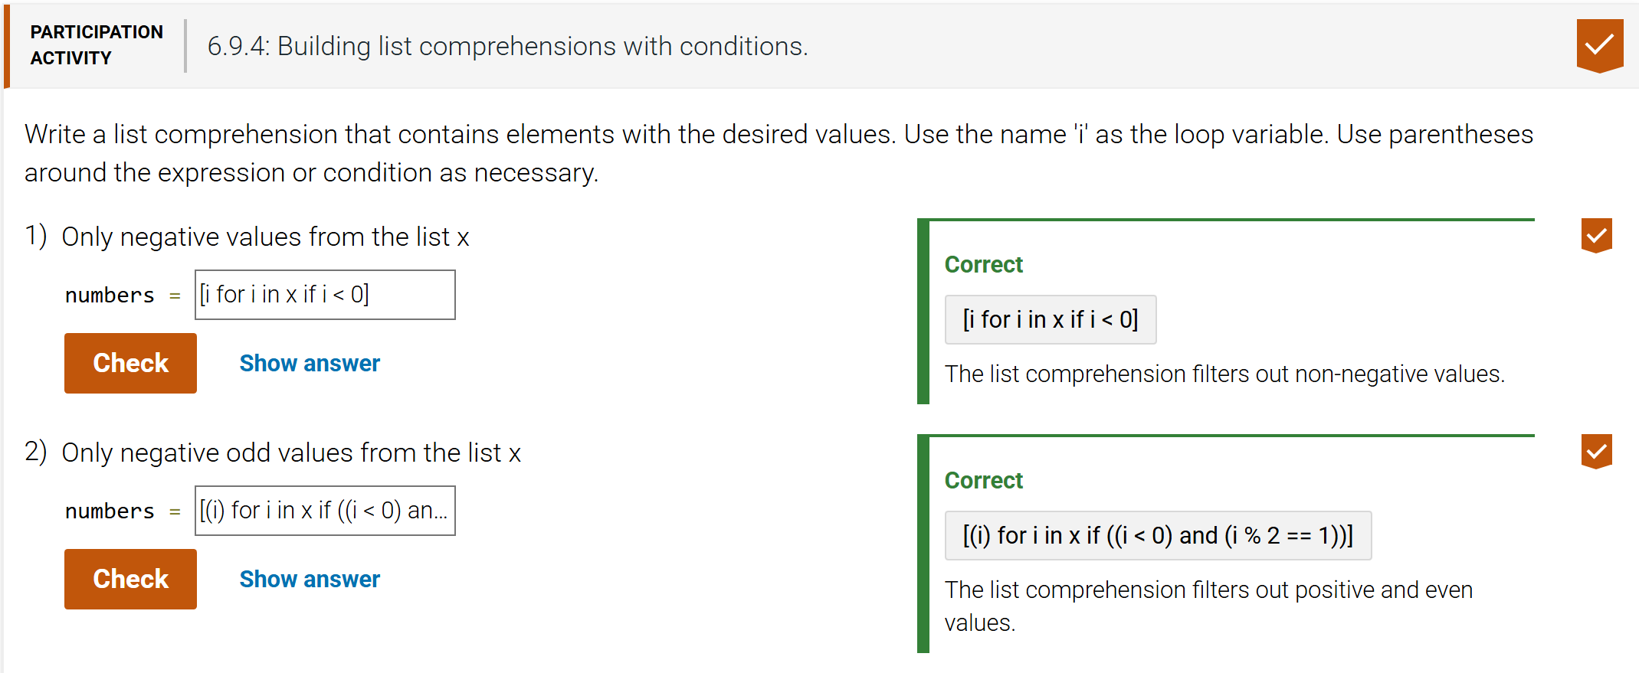
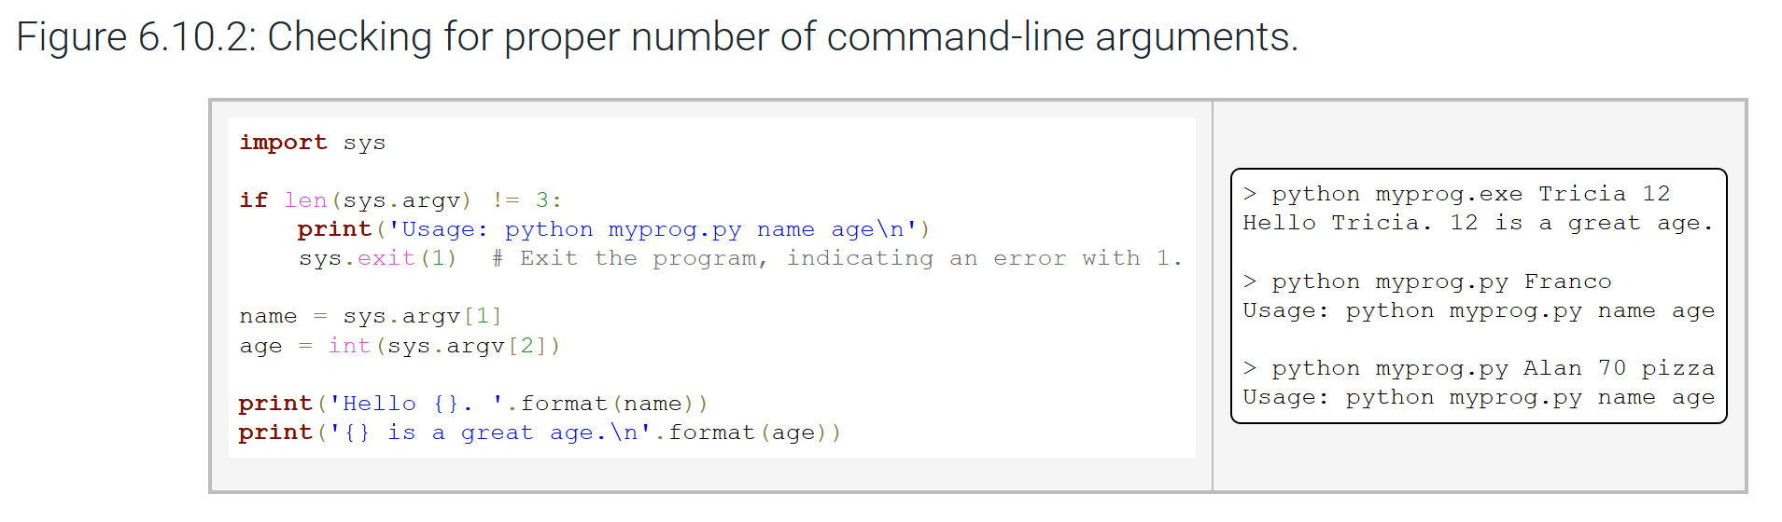
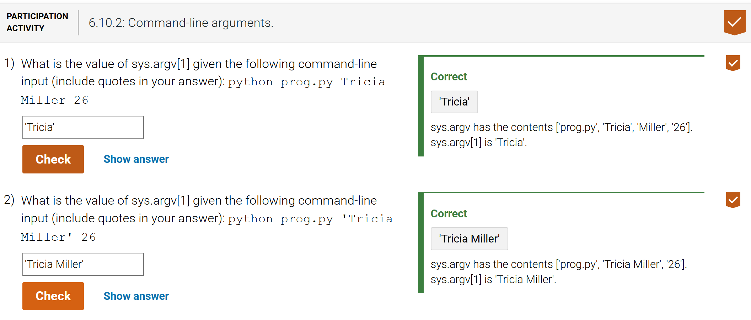
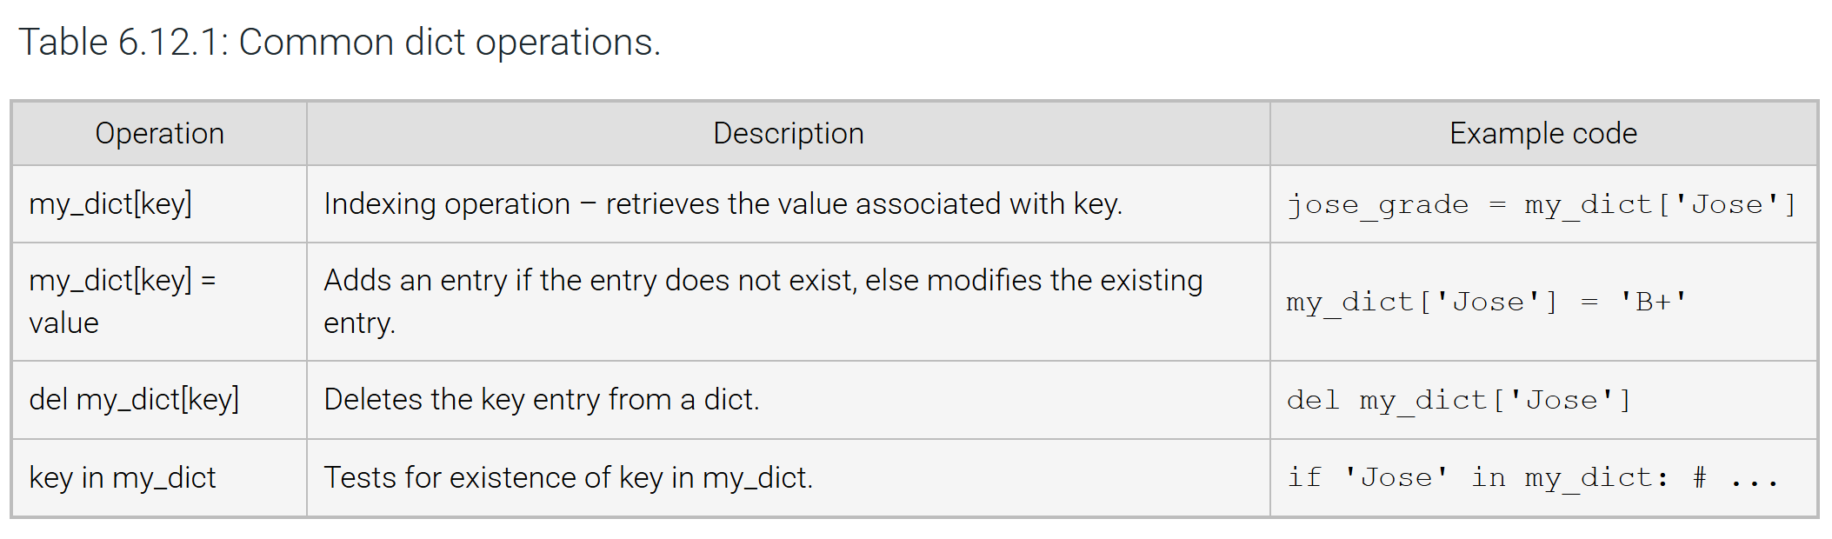
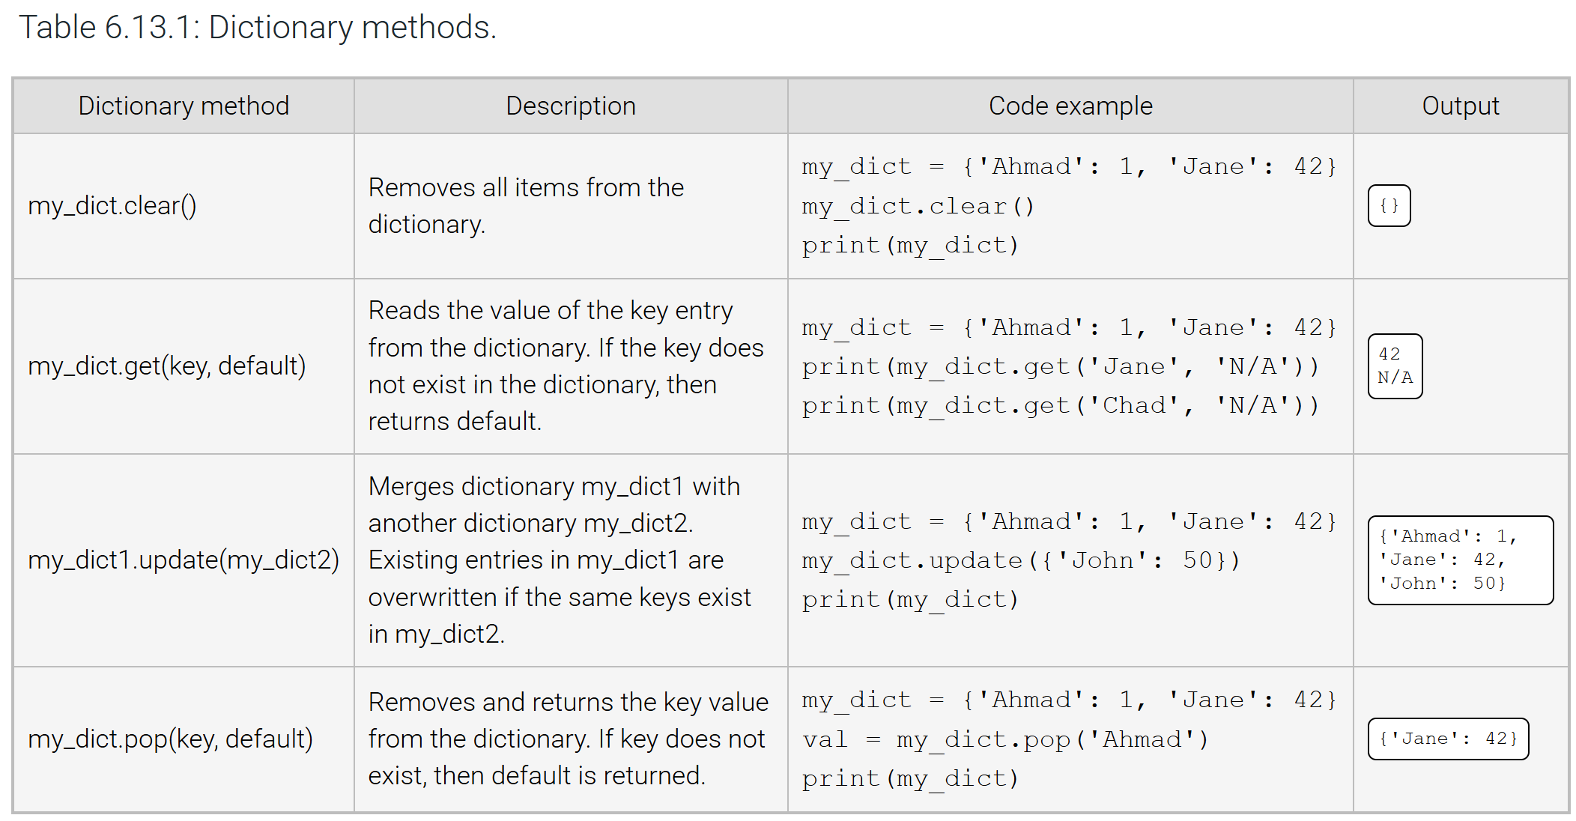
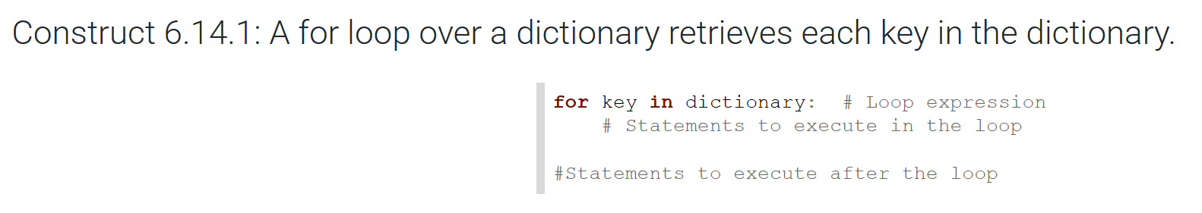
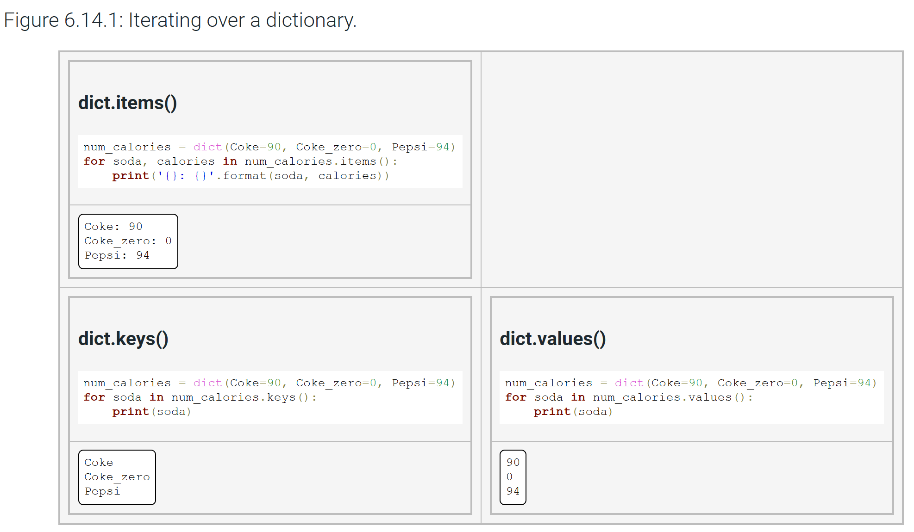
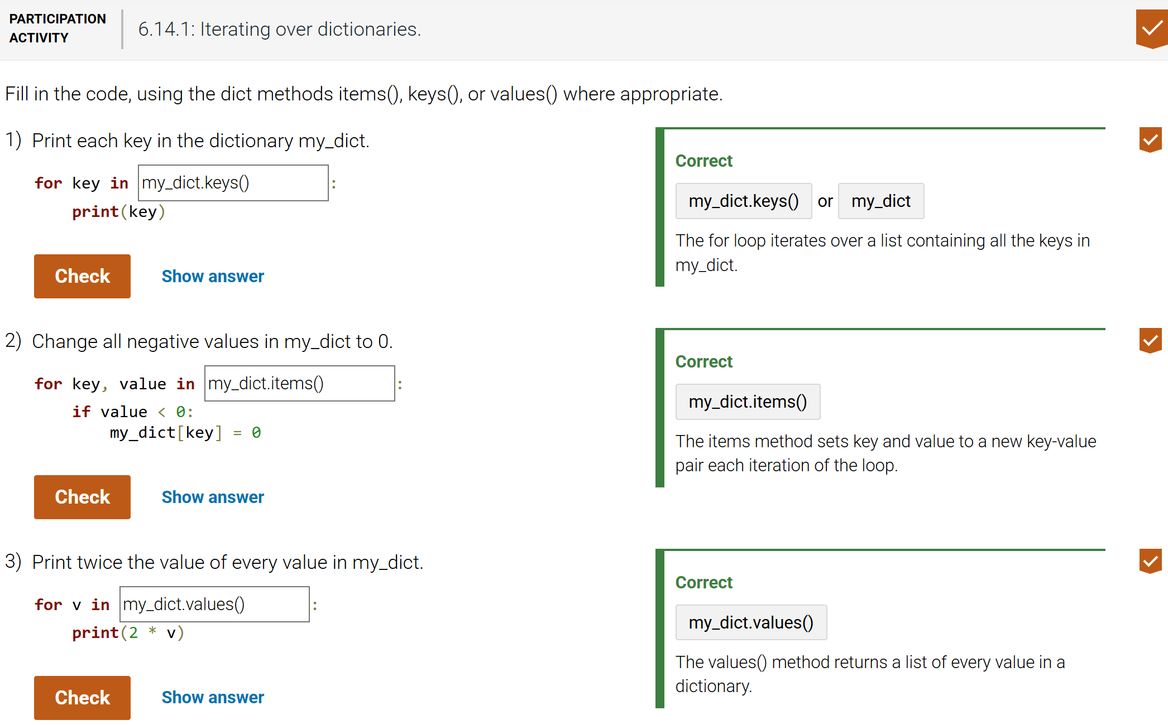
QUESTIONS TO REVISIT / COMMON PITFALL(S):
- A common error when modifying a list during iteration is to update the loop variable instead of the list object.
- A common error is to add or remove a list element while iterating over that list.
- A common error is to try to access a list with an index that is out of the list's index range, e.g., to try to access my_list[8] when my_list's valid indices are 0-7.
- A common error is to access elements within argv without first checking the length of argv to ensure that the user entered enough arguments, resulting in an IndexError being generated.
ADDITIONAL READING(S) / LINKS:
https://docs.python.org/3/library/argparse.html#module-argparse
https://docs.python.org/3/library/getopt.html

